What：
Fresnel equation simulation with multi-user interaction and communication

What is Fresnel equation?:
Fresnel equation is theoretically derived from Maxwell equations, which gives reflectivity and transmissivity of s- and p- polarized light wave:
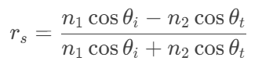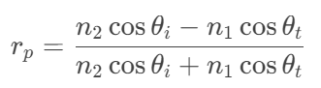

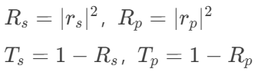
,which corresponds to these part in FoMO20 lecture script:
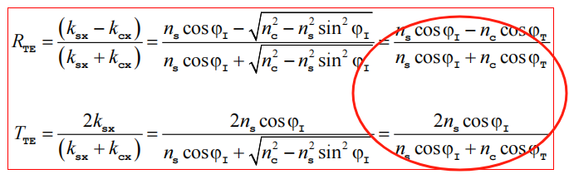

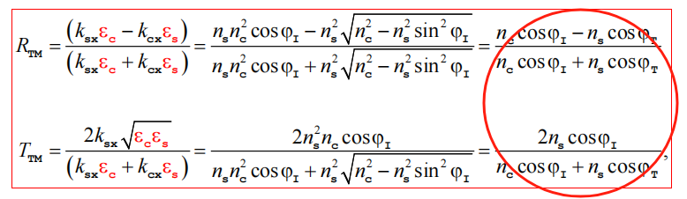
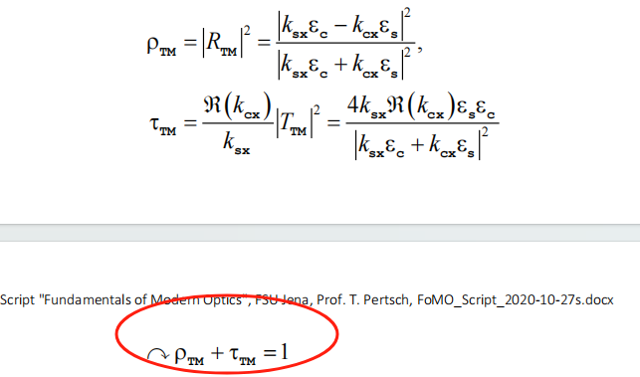

These equations could be visualized like the figure below:
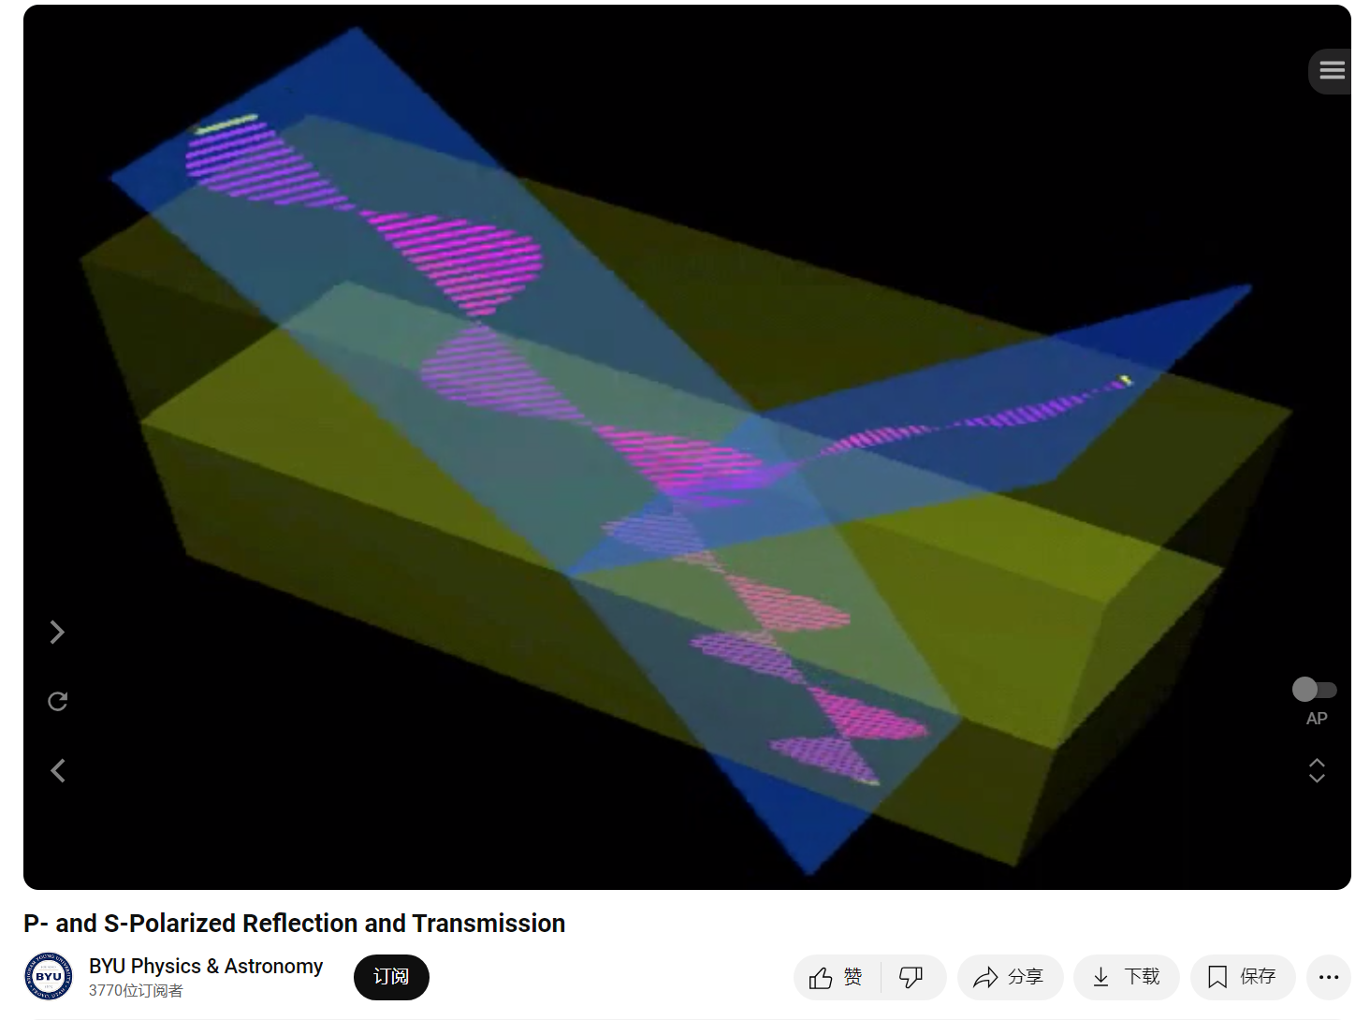

Who：
The app aims at educators, students, researchers who have requirements on knowing how diffraction(reflection and transmission) of EM field(including s- and p- wave) is happening from one medium to another medium. The related optics phenomenon such as Brewster angle and total internal reflection (TIR) can be observed.

Why：
Wave propagation visualization of the prediction by Fresnel Equation. More quantitatively, it could lead to simulation of wave propagation in one-layer systerm or multi-layer system with different optical parameters, which can help educators, students, researchers to have an overall feeling of light propagating between optical mediums. Furthermore, this can help user to study this concept, which is important for design of optical film of camera.

When：
Users can use the app during study and teaching for students about Fresnel Equation. Similarly, it can also be used when researchers want to get an overall feeling of this optical phenomenon, with some basic changeable optical parameters.

Where：
1.Unity can pack the app to work in Windows on normal PC, Android and iOS mobile phone.
2.It can also work in VR devices such as Oculus 2, Oculus 3, and other similar devices, if we pack the app correctly using correspond settings.

The VR interaction part can only be used with suitable VR devices.

How：
prerequisite knowledge: understanding of Fresnel Equation, and how to achieve it in algorithm

The algorithm need to be achieved in Unity using C#.

In Addition, interaction and communication between different users could also be achieved. For e.g., one user can point at some place of the field, change the direction of light, and chat with another person, collaboration can also be achieved for changing the shape or position of the materials together. The size of box-shaped space of FDTD could also be changed, and so on.

- Fresnel part in lecture script of Fundamental of Modern Optics 2020(FoMO20)
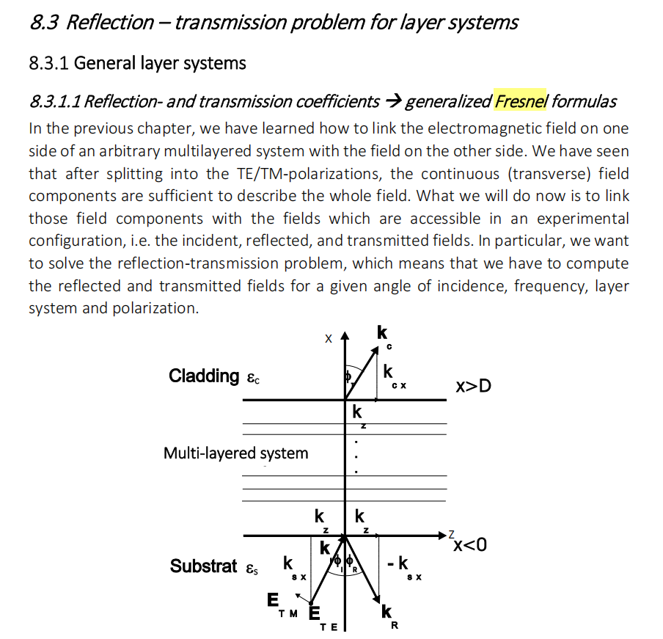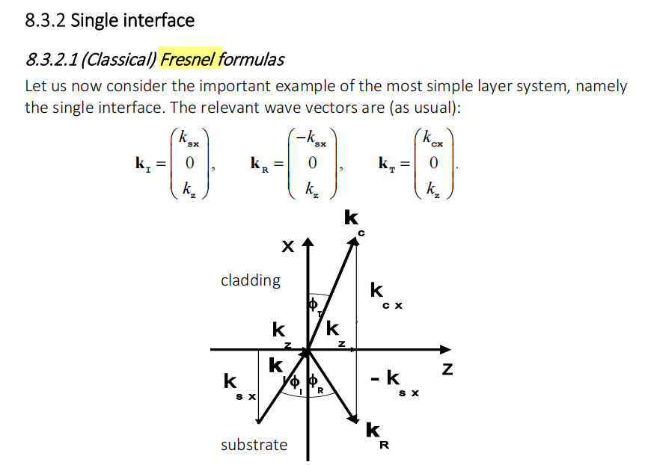

- A video talking about Fresnel Equation with schematic diagrams:
https://www.youtube.com/watch?v=HXIdaY04rjg&t=86s

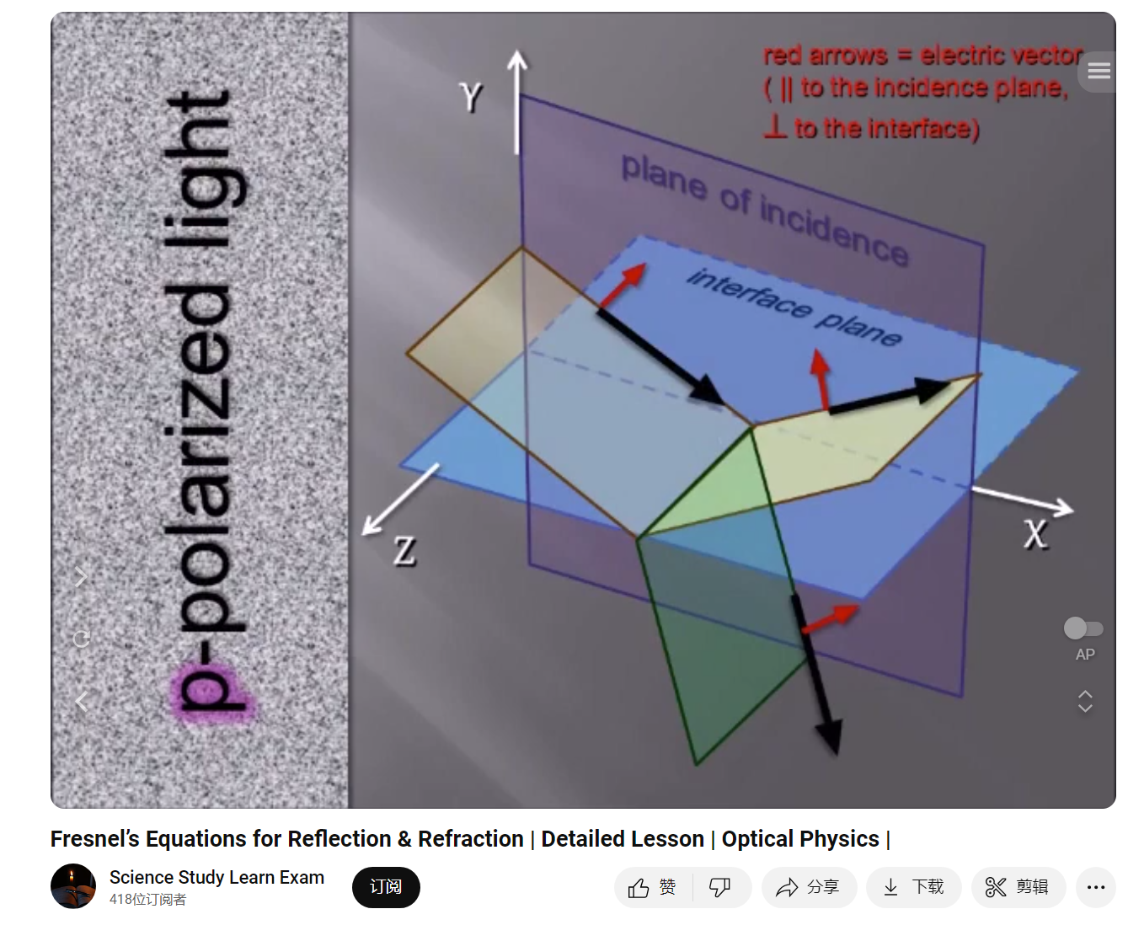

- An basic animation showing EM waves in Fresnel Equation in 3D



